UNIT – II
CORROSION AND CORROSION CONTROL

3.1 INTRODUCTION

Corrosion can be defined as the loss of materials as a result of chemical or electrochemical reaction with the environment. The annual cost of corrosion in India is around Rs. 600 crores. The loss due to corrosion include the cost of repair or replacement of the corroded component or equipments. By making proper use of existing corroded materials and techniques for corrosion prevention, about 25% of the estimated amount (Rs. 150 crores in India) can be saved.

Now a days it is necessary to pay more attention to corrosion because of increasing use of metals in all fields of technology and increase in air and water pollution there by resulting in a more corrosive environment.

Definition :
Metals combines with oxygen gives metal oxide is called corrosion.
Destruction of metals (or) deterioration of metals by the attack of environment is called corrosion.

Causes of corrosion
Metals occur in nature are in the following two forms :
1. Native state
The metals occur in native (or) free (or) uncombined state are non-reactive with the environment. They are noble metals exist as such in the earth crust they have very good corrosion resistance.
Example : Au, Pt, Ag, etc.,

2. Combined State
Except noble metals, all other metals are reactive and react with environment and form stable compounds, as their oxides, sulphides, chlorides, and carbonates. They exist in their form of stable compounds called ores and minerals.

Example : Fe2O3, ZnO, PbS, CaCO3, etc.,

The metal ores are converted into pure metal by the use of metallurgical process. The pure metal at higher energy will always have a tendency to go into the lower energy state by the attack of environment is called corrosion.

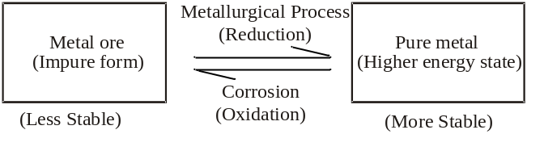

3.2 CLASSIFICATION OF CORROSION

The corrosion process is classified on the basis of mechanisms.
(i) Dry corrosion (or) Chemical corrosion
(ii) Wet corrosion (or) Electro chemical corrosion

3.2.1 Dry Corrosion (or) Chemical Corrosion
This type of corrosion occurs through direct chemical action of dry gases (or) corrodents such as oxygen, halogen, H2S, SO2, etc.,
This can be classified as follows,

(1) Corrosion by oxygen (Oxidation corrosion)
Oxygen present in the atmosphere attacks metal surface resulting in the formation of metal oxide which is known as corrosion product and this process is known as oxidation corrosion.

Mechanism
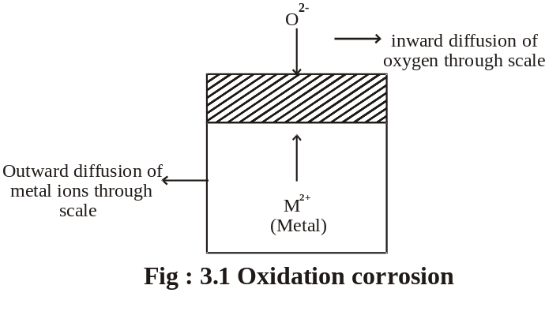

Oxidation first occurs at the surface of the metal resulting in the formation of metal ions (M2+)

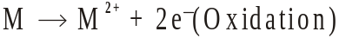

Oxygen is converted to oxygen ion (O2-)

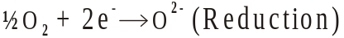

Metal ions combines with oxygen ions forms the metal oxide film

Nature of the metal oxide films formed

There are generally four types of metal oxide films are formed.

(i) Stable film
If the oxide film is stable, there is no further penetration of oxygen ions to the metal part. There is no further corrosion takes place. Thus the stable film act as protective coating.
Examples : Al, Sn, Pb, Cu, etc.,

(ii) Unstable film
In the case of noble metals the metal oxides formed decomposes reversibly to the metal and oxygen.

In this case, the corrosion is a continuous process.
Examples :
Pt, Ag, Au, etc.,

(iii) Porous film
The oxide layer formed in some cases are porous. In this case atmospheric oxygen can easily move to the metal surface.
So corrosion is a continuous process.
Examples :
Li, Na, K, etc.,

(iv) Volatile film
The oxide layer formed in some cases are volatile. So the oxide film volatises as soon as they are formed. The fresh metal surface is kept exposed all the time for further attack. Thus it act as a non-protective coating.

Example :
Molybdenum oxide film.

Pilling - Bed Worth rule
An oxide layer is protective (or) non-porous, the volume of the metal oxide formed is greater than the volume of the metal.
An oxide layer is non-protective (or) porous, the volume of the metal oxide formed is less than the volume of the metal.

(i) Stable film
If the oxide film is stable, there is no further penetration of oxygen ions to the metal part. There is no further corrosion takes place. Thus the stable film act as protective coating.
Examples :
Al, Sn, Pb, Cu, etc.,

(ii) Unstable film
In the case of noble metals the metal oxides formed decomposes reversibly to the metal and oxygen.
In this case, the corrosion is a continuous process.
Examples :
Pt, Ag, Au, etc.,

(iii) Porous film
The oxide layer formed in some cases are porous. In this case atmospheric oxygen can easily move to the metal surface.
So corrosion is a continuous process.
Examples :
Li, Na, K, etc.,

(iv) Volatile film
The oxide layer formed in some cases are volatile. So the oxide film volatises as soon as they are formed. The fresh metal surface is kept exposed all the time for further attack. Thus it act as a non-protective coating.
Example :
Molybdenum oxide film.
Pilling - Bed Worth rule
An oxide layer is protective (or) non-porous, the volume of the metal oxide formed is greater than the volume of the metal.
An oxide layer is non-protective (or) porous, the volume of the metal oxide formed is less than the volume of the metal.

Protective layer metals e.g., Al, Sn, Pb, Cu, etc,.
Non protective metals e.g., Li, Na, K, Mg, Ca, Sr, etc,.

b) Corrosion by other gases
Other gases present in the atmosphere like SO2, CO2, Cl2, H2S etc,. can also attack the metals.
For example,
1. Chlorine attacks on silver forms protective layer of silver chloride, it prevents further corrosion.

2.But Sn reacts with chlorine present in the atmosphere forms SnCl₂.It is volatile. So the corrosion is a continuous process.

3.Metals combines with H2S gas to liberate atomic hydrogen.

The atomic hydrogen is very reactive and penetrate the metal and occupies the voids of the metal.

The atomic hydrogen recombines inside the metal and develop pressure which leads to cracking of the metal. This is known as “Hydrogen Embrittlement”.

4.Atomic hydrogen are formed by dissociation of H2 gas at high temperature.
5. The atomic hydrogen is highly reactive and combine with carbon present in the metal forms CH4 gas which leads to cracking of the metal surface. This is known as “Decarburisation”.

c) Liquid metal corrosion
This type of corrosion is due to the chemical action of flowing liquid metals at high temperature on solid metal.
Such type of corrosion are found in nuclear power plants.

3.2.2 Wet Corrosion (or)
Electrochemical Corrosion

This type of corrosion occurs when,
(i) The conducting electrolytic liquid is in contact with metal.
(ii) Two dissimilar metals are partially dipped in the electrolyte.

In the above condition one part of the metal becomes anode and the remaining part becomes cathode.

In anodic area
Oxidation takes place with the liberation of electrons.
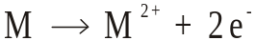

In cathodic area
Depending upon the nature of electrolytic solution, two types of reaction takes place at cathode.

(i) Hydrogen evolution mechanism
(ii) Oxygen Absorption mechanism

This can be explained as follows,

(i) Hydrogen evolution mechanism
When the conduction medium is highly acidic or completely free from dissolved oxygen, hydrogen evolution takes place. For example, corrosion of iron metal by industrial waste containing H+ ion undergoes this type of corrosion.

In this type of corrosion, anodes possess large surface area and less cathode area.

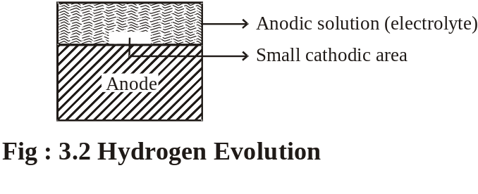

At anode : 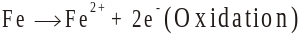
At cathode : 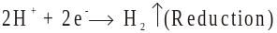
Overall : 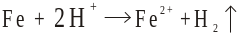

(ii) Oxygen Absorption mechanism
This type of mechanism takes place when base metals are in contact with neutral solution like H2O with dissolved oxygen. An example of this kind of corrosion is the rusting of paint coated iron. If there is any crack in the paint coated iron, that area acts as anode.
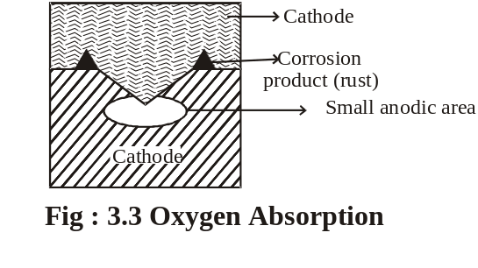
The liberated electrons flows from the anode to the cathode through the metal and accepted along the electrolyte and oxygen at cathode.

At anode : 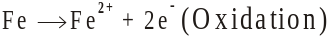
At cathode :
Overall :

If enough oxygen is present, ferrous hydroxide is converted into ferric hydroxide.

Table 3.1 Differences Between Chemical and Electro Chemical Corrosion
Sl.  No | Dry (or)  Chemical Corrosion | Wet(or)Electro Chemical Corrosion
1. | It occurs in dry state | It occurs in presence of moisture (or) electrolyte
2. | It follows adsorption mechanism | It follows the mechanism of electro chemical reaction.
3. | Corrosion product accumulate on the same spot, where corrosion occurs. | Corrosion occurs at anode while products gather at cathode
4. | Uniform corrosion behaviour is seen, i.e., either the whole surface of the metal in contact with the medium corrodes, or it does not. | Localised corrosion occurs. i.e., one metal surface alone is corroding even though both metal surfaces are in contact with the medium.
5. | Only heat evolution can be observed. | Due to electron flow from the site of oxidation to site of reduction, current flow can be observed.
3.2.3 Galvanic Corrosion
This type of electrochemical corrosion takes place when two dissimilar metals are joined in the presence of electrolyte. The metal with higher negative electrode potential acts as anode and the remaining parts acts as cathode.

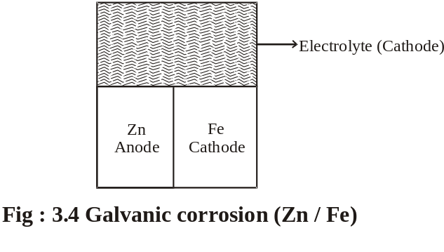
At anode : 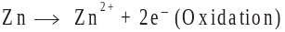
At cathode :
Overall :

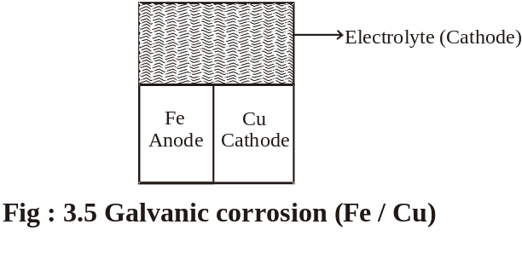
At anode : 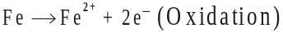
At cathode : 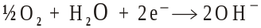
Overall :
The galvanic corrosion can be avoided by

1. Coupling of metals very close in the emf series.
2. Providing an insulating material between the two metals.
3.The area of the cathode is always smaller than anodic area.

3.2.4 Concentration Cell Corrosion (or)
Differential Aeration Corrosion
This is the most common type of electrochemical corrosion that takes place when the metal is partially dipped in solutions, metals partially covered with dust, sand, water drops etc. The less aerated part act as anode and the more aerated part act as cathode. The anodic part undergo corrosion and the cathodic part is prevented. This type of corrosion called as Concentration Cell Corrosion.

Example : 1
When a metal is partially immersed in a solution it has very poor aeration when compared with the metal that is outside the solution.
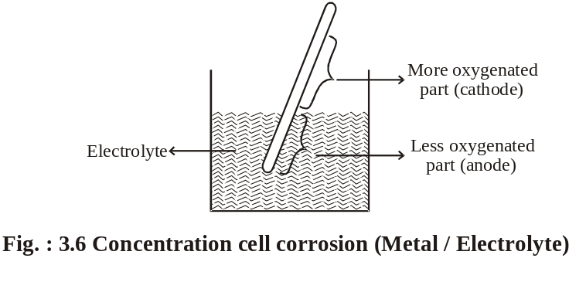
The less aerated part act as anode and the more aerated part act as cathode.
Example: 2
The another example of this type of corrosion is the metal parts partially covered with dust, sand, water drops etc. This type of corrosion is called as pitting corrosion.
Pitting Corrosion
Pitting is a localized attack, resulting in the formation of a hole around which the metal is relatively unattached.

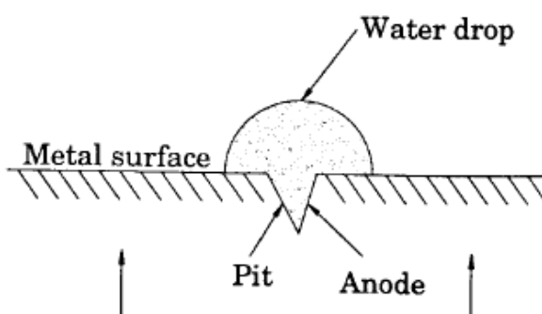
Cathode

Fig Pitting Corrosion

The area covered by the drop of water act as an anode due to less oxygen concentration and suffers corrosion. The uncovered area (freely exposed to air) act as a cathode due to high oxygen concentration.
The rate of corrosion will be more, when the area of cathode is larger and the area of anode is smaller.

At anode : 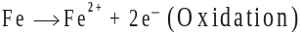
At cathode :
Overall
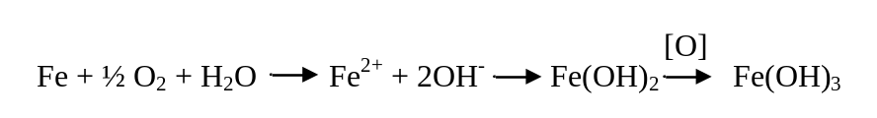
This type of intense corrosion is called pitting.

Example: 3
Differential aeration corrosion may also occur in different parts of pipeline. The buried pipelines (or) cables passing from one type of soil to another, say, from clay (less aerated) to sand (more aerated) may get corroded due to differential aeration.

Example: 4
This type of corrosion is also takes place in wire fence. In this case the areas where the wires cross are less aerated than the other parts of the fence. The corrosion takes place at the wire crossings because less aerated part act as anode.

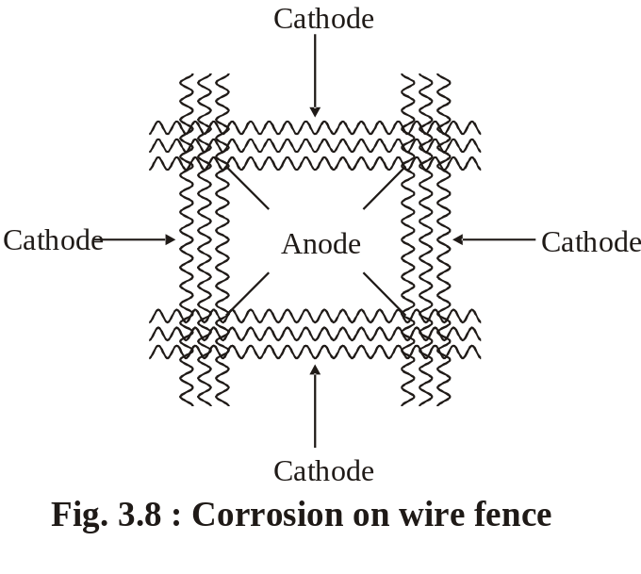
3.3 STRESS CORROSION

Stress corrosion is the combined action of a tensile stress and the corrosive environment on a metal. This type of corrosion is seen in fabricated articles of certain alloys due to stress, but pure metals are immune to stress corrosion.

Conditions for stress corrosion to occur:
i) due to the presence of tensile stress
ii) A specific corrosive environment such as
a) For mild steel- caustic alkali & strong nitrate solution.
b) For brass –traces of ammonia solution.
c) For stainless steel-acid chloride solution.

Stress corrosion is an electrochemical corrosion. Presence of stress in a metal ( due to bending ) produces strains, which forms anodic part, while the remaining part acts as cathodic part.

Corrosion reactions
At Anode : Fe → Fe²⁺ + 2e⁻
At Cathode : 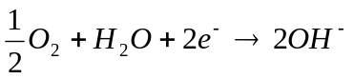
(O)
Net reaction : 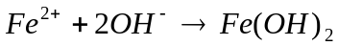 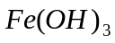

Thus the stressed part is easily attacked, even by a mild corrosive environment, resulting in the formation of crack.

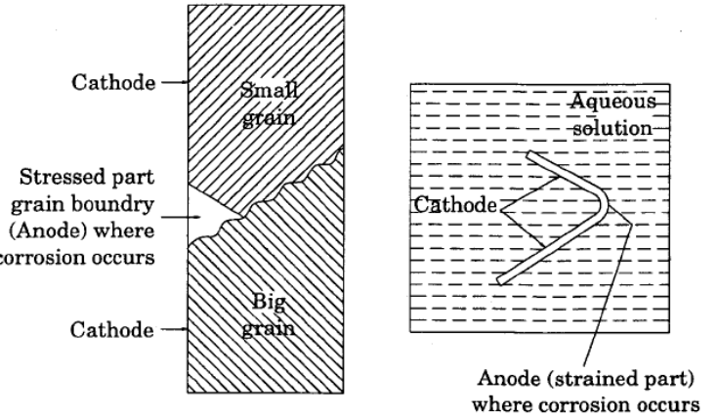

Stress corrosion

Fig

Prevention
i) Giving suitable treatment to relieve internal stresses.
ii) Adjusting the composition and eliminating impurities.
iii) Selecting more resistant material
iv) Removing corrosive environment.

Examples of Stress Corrosion

1. Season Cracking

Seasonal cracking is a term applied to stress corrosion of copper alloys (brass).
This corrosion is due to the high residual stresses present in the brass as a result of cold working. These stresses make the bras more susceptible to intergranular corrosion in presence of ammonia or amines.

i.e., Cu + 4 NH₃ [ Cu(NH₃)₄]² + (soluble)

This is the real cause of dissolution of brass, which is the reason for cracks.

2. Caustic embrittlement
It occurs in mild steel, when it is exposed to alkaline solutions at high temperatures and stresses.
Boiler water usually contains a certain proportion of sodium carbonate, added for water softening purposes. In high pressure boilers this breaks up to give sodium hydroxide and carbon dioxide.

Na₂CO₃ + H₂O 2NaOH + CO₂ ↑

The NaOH flows into the minute hair cracks and crevices usually present on the boiler material by capillary action and dissolves the surrounding area of iron as sodium ferroate.

Fe + 2NaOH Na₂FeO₂ + H₂ ↑

This causes brittlement of boiler parts, particularly stressed parts like bends, joints, rivets, etc., causing failure of the boiler.

Prevention
1. by adding sodium sulphate to the boiler water instead of sodium carbonate.
2. By adding tannin, lignin to the boiler water which blocks the hair cracks.

Soil or underground corrosion

Factors influencing soil corrosion
The various factors that influences soil corrosion are
i) Acidity of the soil
ii) Moisture and electrolyte contents.
iii) Presence of micro-organisms and bacterias.
iv) Content of organic matter
v) Texture ( physical properties) of the soil

Classification of soil corrosion
Based on the particle size, soils are classified into the following six types.

1. Gravel or Sandy soils
Soils rich in gravel and sand are more porous and hence are generally more aerated. If a metal pipe is buried in such a soil, the corrosive conditions are similar to those of oxygen concentration cell corrosion, the rate of corrosion is governed by the amount of moisture content in the soil.

2. Water- logged soils
Water-logged soils contain very small amount of free oxygen, but various bacterias and micro-organisms can grow. This leads to micro-biological corrosion.

3. Intermediate character soils
This type of soil may produce a localized corrosion. If air pockets are present, differential aeration corrosion may occur in different parts.
4.Soil with large amount of organic matter
If the soil contains large amount of organic matter, the formation of soluble metal complexes and peptization of corrosion product may accelerate the corrosion process as compared to the soils, which are relatively free from organic matter.

5.Non-acids soils
In non-acid soils, the conductivity ( which depends on moisture and electrolyte content) is the major factor governing the corrosive character. In such soils, corrosion follows differential aeration type corrosion. The rate of corrosion mainly depends on
i) the resistance between the anodic and cathodic areas.
ii) the rate of arrival of the oxygen to the cathodic areas.

Thus, when a pipe passes under a paving, the portion under the paving has less access to oxygen than the one lying under unpaved soil. Hence, the portion under the paving becomes anodic and suffers corrosion.
6. Highly acidic soils
In highly acidic soils, the conductivity is not of much importance. In such soils, corrosion follows hydrogen evolution type corrosion. The rate of corrosion mainly depends on
i) the pH of the soils
ii) the presence of salt and oxygen etc.,

Water line corrosion
Water line corrosion is also called as differential aeration corrosion leading to the formation of oxygen concentration cell. It occurs due to the storage of water in a metal container.

Example:
Water stored in a steel tank (Fig )

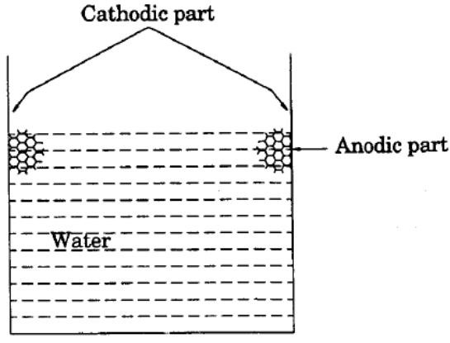
Fig water line corrosion

When water is stored in a steel tank, corrosion occurs along the line just beneath the water meniscus. The highly oxygenated area ( above the water line) acts as the cathode and is unaffected by corrosion, while the poorly oxygenated area ( beneath the water line) acts as anode and highly affected by corrosion.
Corrosion reactions
At Anode : Fe → Fe²⁺ + 2e⁻
At Cathode :
(O)
Net reaction : Fe²⁺ + 2OH → Fe(OH)₂ Fe(OH)₃

Draw back: Water line corrosion is a serious problem for ocean going ships.
Prevention: using special “ antifouling paints”.

Microbiological corrosion
Corrosion caused by the metabolic activity of various micro-organisms is called microbiological corrosion. The micro-organisms can develop and propagate in an environment in the presence (or) absence of oxygen. Therefore they are termed as aerobic corrosion and anaerobic corrosion.

Types of micro-organism ( microbiological corrosion)
Following three types of micro-organisms are responsible for microbiological corrosion.
1. Aerobic micro-organism ( aerobic corrosion)
a) Sulphur bacteria ( e.g., thiobacillus)
It oxidizes sulphur present in their cells to give sulphuric acid, which attack the metals like iron. This type of bacterias grow in acidic conditions of pH from 0 to 1.

b) Iron and manganese micro-organisms
These bacterias live by taking into their cells iron and manganese ions. The bacteria digest them in the presence of oxygen, forming insoluble hydrates of iron and manganese dioxide, which are then thrown out their bodies. Iron bacterias grow in stagnant or running water at 5 to 40ºC and pH from 4 to 10.
II) Anaerobic micro-organisms (Anaerobic corrosion)
a) Sulphate reducing bacterias ( e.g., sporovobrio desulphuricous)

They are responsible for anaerobic corrosion of iron and steel. They require sulphate and oxygen for their nourishment. The optimum conditions for their growth are 25-30ºC and pH from 5 to 9.

Mechanism
Anodic solution of iron
8H₂O → 8H⁺ + 8OH⁻
4Fe + 8H⁺ → 4Fe²⁺ + 8H

Depolarization due to activity of bacterias
H₂SO₄ + 8H⁺ → H₂S + 4H₂O

Corrosion product

Fe²⁺ + H₂S → FeS + 2H⁺

3Fe²⁺ + 6OH⁻ → 3Fe(OH)₂

III) Film forming micro-organisms
Example : Bacterias, fungi, algae & diatoms

This type of micro-organisms form microbiological film on an iron surface, which can take acids, salts and gases from the surface of iron, leading to the formation of local biological concentration cells and consequent corrosion.

3.3 Intergranular Corrosion

Introduction
This type of corrosion is due to the fact that the grain boundaries contain material which shows electrode potential more anodic than that of the grain centre in the particular corroding medium.

This may be due to precipitation of certain compounds at the grain boundaries, thereby leaving the solid metal solution impoverished (or) depleted in one constituent.
The impoverished solid solution is anodic with respect to the grain centres as well as to the precipitated compound, so that it will be attacked preferentially by the corrosive environment.

Fig. 3.9 General intergranular attack

This type of corrosion is generally encountered in alloys.

For example,
During the welding of stainless steel (an alloy of Fe, C and Cr), chromium carbide is precipitated at the grain boundaries, thereby, region just adjacent to grain boundaries becomes depleted in chromium composition and is more anodic with respect to the solid solution within the grain.(which is richer in chromium).

Intergranular corrosion follows the path of grain boundaries and occurs on microscopic scale, without any apparent external signs of any intensive attack. On account of this, sudden failure of material occurs (without any pre-washing) due to loss of cohesion between grains.

Remedy
The remedy is proper heat-treatment, followed by rapid quenching to avoid the heterogeneous precipitation that, usually, occurs due to slow-cooling.
3.4 FACTORS INFLUENCING RATE OF CORROSION

Corrosion is a kind of reaction that takes place in the metal by the influence of its environment. Hence both (i) the nature of the metal & (ii) the nature of environment play equal part in the corrosion of the metal. The following are the factors responsible for the corrosion.

I. Nature of the Metal
(a) Position of metal in the EMF series
Metals higher (-) in the galvanic series undergo strong corrosion and lower (+) in the EMF series undergo less corrosion.

(b) Relative areas of anode and cathode
Corrosion will be severe if the anodic area is small and the cathodic area is large. Larger cathodic area of the cathode will create demand of more electrons, which can be met by the smaller area of the anode only by undergoing more corrosion.

(c) Over potential
Corrosion is very slow if hydrogen over voltage of the cathodic metal is high. The over potential of a metal in a corrosive environment is inversely proportional to corrosion rate.

(d) Nature of the surface film
Stable oxide film restricts further corrosion. Unstable, volatile and porous oxide films enhances further corrosion.

(e) Purity of the metal
Impurity present in pure metal creates heterogenity and leads to galvanic corrosion. If the percentage of purity increases the corrosion rate decreases.
(f) Stress
Metals part under stress can become anode and undergo corrosion. This type of corrosion is called stress corrosion.

II. Nature of the Environment

(a) Temperature
Increase of temperature increases diffusion of ions in the corrosive medium and thus rises the corrosion rate.

(b) Humidity
Concentration of water vapour present in the atmosphere is known as humidity. If the humidity increases the corrosion rate increases, at a particular point a sudden increase in the corrosion rate is observed, that is called critical humidity.
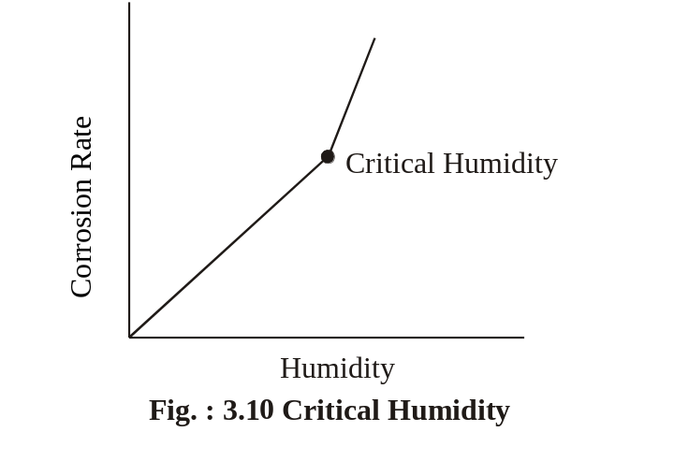
(c) Presence of Corrosive gases
Corrosive gases like So2, H2S, fumes of HNO3, H2SO4, acetic acid etc, enhances the corrosion rate.
(d) Presence of suspended solids
Suspended particles like chemically active, chemically inactive
and chemically neutral dust particles enhances the corrosion rate.
(e) pH
The corrosion rate is maximum when the environment is more acidic (pH=5) and minimum when the environment is more alkaline (pH=11). In general, acidic medium is more corrosive than alkaline or neutral medium.

3.5 CORROSION CONTROL METHODS

The corrosion is controlled by the following methods.
(i) Sacrificial anodic protection
(ii) Impressed current cathodic protection
iii) Control of corrosion by modifying the metal
(iv) Corrosion Inhibitors.

3.5.1 Sacrificial Anodic Protection Method
In this method, the metallic structure to be protected is made cathode by connecting it with more active metal (anode metal). So that all the corrosion will concentrate only on the active metal. The artificially made anode thus gradually corroded protecting the original metallic structure. Hence, this process is otherwise known as sacrifical anodic protection.

Aluminium, Zinc, Magnesium are used as sacrificial anodes.

This method is used for the protection of ships and boats. Sheets of Mg or Zn are hung around the hull of the ship. (Fig. 3.11).

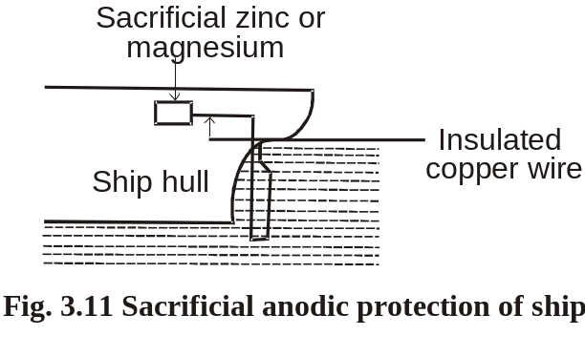
Zn or Mg will act as anode compared to iron (ship or boat is made of iron), so corrosion concentrates on Zn or Mg. Since they are sacrificed in the process of saving iron, they are called sacrificial anodes.
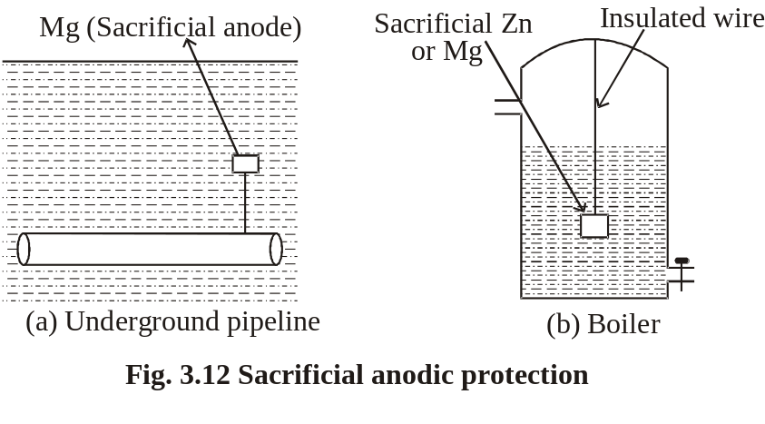

Important applications of sacrificial anodic protection are

a. Protection of underground pipelines, cables from soil corrosion (Fig. 3.12(a)).
b. Insertion of Mg sheets into the domestic water boilers to
prevent the formation of rust (Fig. 3.12(b)).
c. Calcium metal is employed to minimize engine corrosion.

3.5.2 Impressed Current Cathodic Protection Method
In this method, an impressed current is applied in the opposite direction of the corrosion current to nullify it, and the corroding metal is converted from anode to cathode.
This can be done by connecting negative terminal of the battery to the metallic structure to be protected, and positive terminal of the battery is connected to an inert anode. Inert anodes used for this purpose are graphite, platinised titanium. The anode is burried in a “back fill” (containing mixture of gypsum, coke, breeze, sodium sulphate). The “back fill” provides good electrical contact to anode (Fig. 3. 13).
Important applications of impressed current cathodic protection are structures like tanks, pipelines, transmission line towers, marine piers and laid-up strips, etc.

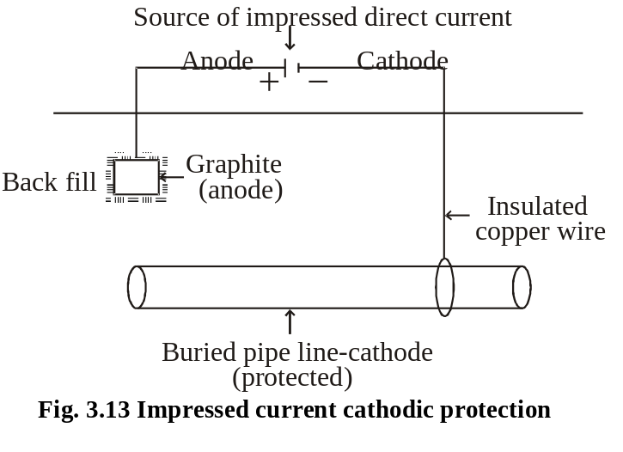

This type of protection is given to underground water pipe lines, oil pipe lines, ships, etc.

Table 3.2 Comparison of Galvanic method (Sacrificial anode) and Impressed current cathodic method

Sl.No | Sacrificial anode method | Impressed current method
1. | No external power supply is necessary. | External power supply must be present.
2. | This method requires periodical replacement of sacrificial anode. | Here anodes are stable and do not disintegrate.
3. | Investment is low. | Investment is more.
4. | Soil and microbiological corrosion effects are not taken into account. | Soil and microbiological corrosion, corrosion effects are taken into account.
5. | This is most economical method especially when short-term protection is required. | This method is well suited for large structure and long term operations.
6. | This method is suitable when the current requirement and the resistivity of the electrolytes are relatively low. | But this method can be practiced even if the current requirement and the resistivity of the electrolyte are high.

3.5.3 Corrosion Inhibitors
A corrosion inhibitor is a substance which reduces the corrosion of a metal, when it is added to the corrosive environment.

Types of Inhibitors
1. Anodic Inhibitors
Examples : Chromates, nitrates, phosphates, tungstates (or) other ions of transition elements with a high oxygen content.
Anodic inhibitors are those that prevent the corrosion reaction, occurring at the anode, by forming an insoluble compound with the newly produced metal ions. These precipitates are adsorbed on the metal (anode) surface, forming a protective film and reducing the corrosion rate.
Though this type of control is effective, it may be dangerous, since sever local attack can occur, if some areas are uncovered.

2. Cathodic Inhibitors
In an electrochemical corrosion, the cathodic reactions are of two types depending upon environment.

(a) In An Acidic Solution
Examples : Organic inhibitors heterocyclic nitrogen compounds, heavy metal soaps.
In an acidic solution, the cathodic reaction is evolution of hydrogen i.e., like amines, mercaptans, thioureas, substituted ureas, etc.,
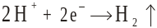

The corrosion can be reduced in two ways
(i) By slowing down the diffusion of H+ ions to the cathode. This can be done by adding organic inhibitors like amines, pyridines, etc., which are adsorbed at the metal surfaces.
(ii) By Increasing the over voltage of Hydrogen evolution. This can be done by adding antimony and arsenic oxides which deposit adherent film of metallic arsenic and antimony at the cathodic areas.

(b) In a Neutral Solution
Examples :
Sodium sulphite (Na2SO3), hydrazine (N2H4).
In a neutral solution, the cathodic reaction is

The corrosion can be reduced in two ways.
(i) By eliminating the oxygen from the neutral solution, there by formation of OH- ions are inhibited. This can be done by adding reducing agents like Na2SO3, N2H4 etc.
(ii) By eliminating the OH- ions from the neutral solution. This can be done by adding Mg, Zn or Ni salts. These react with OH- ions form insoluble hydroxides, which are deposited on the cathode forming less impermeable self - barriers.

3. Vapour Phase Inhibitors (VPI)
Examples : Dicyclohexylammonium nitrate, benzotriazole, etc.
Vapour phase inhibitors (VPI) are organic inhibitors, which readily vapourise and form a protective layer on the metal surface. VPI are used in the protection of storage containers, packing materials, sophisticated equipments, etc.

iv) Control of corrosion by modifying the metal

1. By selection of the metal
Selection of right type of metal is the main factor for corrosion control. Thus, noble metals are used in ornaments and in surgical instruments.

2. By using pure metal
Pure metals have higher corrosion resistance. Even a small amount of impurity may lead to severe corrosion.

3. By alloying
Corrosion resistance of many metals can be improved by alloying. For example, stainless steel containing chromium produce a coherent oxide film, which protects the steel from further attack.

4. By proper design
Some of the important rules for designing, which must be observed are given below.

i) Avoid galvanic corrosion
If two different metals are joined , galvanic corrosion will occur. In such a case galvanic corrosion is prevented by
a) Selecting the metals as close as possible in the electrochemical series.
b) Providing smaller area for cathode and larger area for anode.

Fig

c) Inserting an insulating material between the two metals. (Fig)

ii) Drainage affects corrosion
Tanks and other containers must be designed in such a way that, the whole of the liquid should be drained off completely. (Fig)

iii) Avoid sharp corners and bends
Sharp corners and bends should always be avoided, and hence erosion corrosion can be avoided by smooth corners or curved pipe bends (Fig ).

Fig

iv) by avoiding crevices
Crevices allow moisture and dirt, which results in increased electrochemical corrosion. This can be prevented by filling the crevices with a filler (Fig ).
Example : Riveted joints produce crevice corrosion, so welded joints are preferred.

3.9 PAINTS

Paints are stable mechanical mixtures of one (or) more pigments.
Paint is a dispersion of pigments in to the drying oil.
The vehicle or drying oil is a film forming material, to which other ingredients are added in varying amounts.

Requisites (or) Characteristics of a good Paint
It should spread easily on the metal surface.
It should have high covering power.
It should not crack on drying.
It should adhere well to the surface.
The colour of the paint should be stable.
It should be a corrosion and water resistant.
It should give a smooth and pleasing appearance.
It should dry quickly.

Pigment Volume Concentration (P.V.C) of a paint is an important criterion or a guide for the paint manufacturer to prepare paints with desired properties.

Generally, the characteristics of paints depends on the nature and quantities of pigments, extenders and vehicles present in the paint.
Pigment Volume Concentration (P.V.C)
It is an important property of a paint.

The following equation is used to calculate the P.V.C

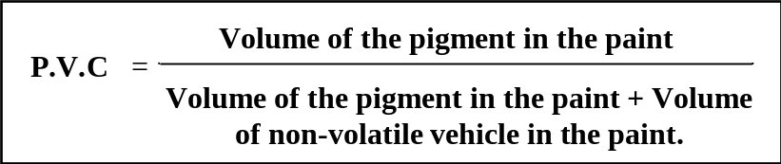

If the volume of P.V.C increases, the durability, adhesion and consistency of the paint decreases.

The pigment volume concentration of a paint should be kept within the limit.

3.9.1 CONSTITUENTS OF PAINTS
The impartant constituents of paints are as follows
1. Pigments 2. Vehicle 3. Drier 4. Thinner
5. Antiskinning agent 6. Plasticizers 7. Filler

Table 3.3 Constituents of Paints and their Functions

Sl.No | CONSTITU-ENTS | FUNCTION | EXAMPLE
1. | Pigments | i) To give the desired colour  ii) To cover the manufacturing defects  iii) To protect from U-V light | White: Pb,TiO₂,  ZnO Blue : Indigo  Red: Red lead, chrome red.  Green: Chromium oxide, Cr-green  Yellow: Cr-yellow,  Cd-yellow  Black: Graphite, carbon black.
2. | Thinner | Used to dilute the paints in order to make it easy to apply on the surface. | Turpentine oil, Kerosene, Alcohol
3. | Vehicle or Drying oil | It is used to dissolve the pigment | Coconut oil, Linseed oil, Castor oil, Soyabeen oil.
4. | Driers | They act as catalysts and increase the rate of drying process | Litharge, Oxides of Mn and Co.
5. | Antiskinning agent | To prevent skinning of the paint. | Polyhydroxy phenol
6. | Plasticizers | They increase the elasticity of the film. | Triphenyl phosphate, tributyl phosphate, tertiary amyl alcohol.
7. | Fillers | They increase the volume of the paint reduce the cost. | Gypsum, asbestos, china clay, talc, BaSO₄

3.9.2 MECHANISM OF DRYING OF (PAINTS) DRYING OILS
1. Drying oils are fatty oils which are extracted from seeds.
2. The fatty oils are triesters of glycerol.
3. Formula of fatty oil (Drying oil) is
R₁COO
CH
CH₂ COOR₂
CH₂ COOR₃

where R1, R2, R3, are radicals derived from aliphatic unsaturated acids (Palmitic acid, Oleic acid)

4. The paint containing these type of drying oils, when exposed to air becomes a cross-linked polymer by reaction with oxygen in the atmosphere.

5. In general, oils containing fatty acids having conjugated double bonds dry faster than those that have non-conjugated double bonds.

6. The mechanism of drying oils has not been completely understood. However, according to acceptable mechanism, the following points are given
i) The oil combine with oxygen to form peroxides.
ii) The film takes of oxygen continuously and decomposes.
iii) The peroxy radicals combine to give cross-linked polyperoxides which are stable.
iv) These polyperoxides are decomposed by light and heat to form other linkages.

Mechanism

1. The oil after application to the surface it becomes solidifies. It is said to “dry up”. Hence it is called as “drying oil”.

2. These oils contain unsaturated esters.

3. The double bonds in them absorb oxygen from the air and form peroxides (with 0 - 0) linkages first and these linkages react with adjacent chain unsaturation centres and form cross links.
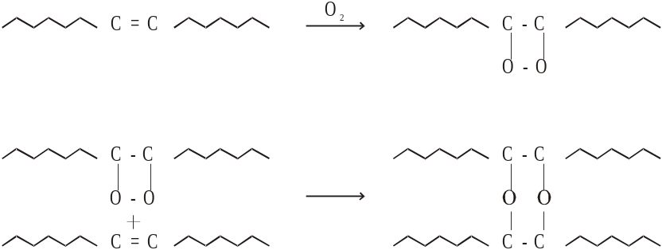

These cross links when continued sufficiently solidify the liquid oil. This is only one of the mechanisms that is possible.

Generally, the more the unsaturation centres (carbon - carbon double bonds) the more is the capacity for O2 absorption and quick “drying” (or) solidification.

3.9.3 SPECIAL PAINTS
Apart from being used for protection from corrosive atmospheres, for decoration, for reflecting away heat etc., paints have been formulated for special purposes (or) uses are called as special paints.

Some of the important special paints are as follows

(i) Fire Retardant Paints
These paints contains ingredients like calcium ammonium phosphate, magnesium ammonium phosphate, calcium carbonate etc.,
Under intense heat, they decompose to give CO2, NH3, H2O for these gases (non - inflammable gases) cover the flame quickly and extinguish the fire.

Uses
This is mainly used in wooden houses.

(ii) Temperature Indicating Paints
This paint contain ingredients like amine salts of copper, iron, manganese, cobalt and nickel.
These substances undergo colour changes and indicating a particular temperature.

Uses
Used in the outerwalls of the reactors and furnaces to indicate the temperature by its colour change.

(iii) Water Repellant Paints

This paints consists of silicones which is dissolved in suitable solvent with required amount of pigments.
Paints containing asphalt or bitumens are also used for water proofing.

Uses
Used in ships, boats and marine equipments.

(iii) thicker oxide coating and hence it is more protective

3.6 PROTECTIVE COATINGS

Introduction
Protective coatings are used to protect the metals from corrosion. Protective coatings act as a physical barrier between the coated metal surface and the environment. However they are also used for the decorative purpose. In addition to corrosion protection and decoration, they import some special properties such as hardness, electrical properties, oxidation-resistance and thermal insulating properties to the protected surface.

Coatings like paints, varnishes, lacquers and enamels are called organic coatings. They are applied on the metallic surfaces for both corrosion resistant and decoration.

Classification
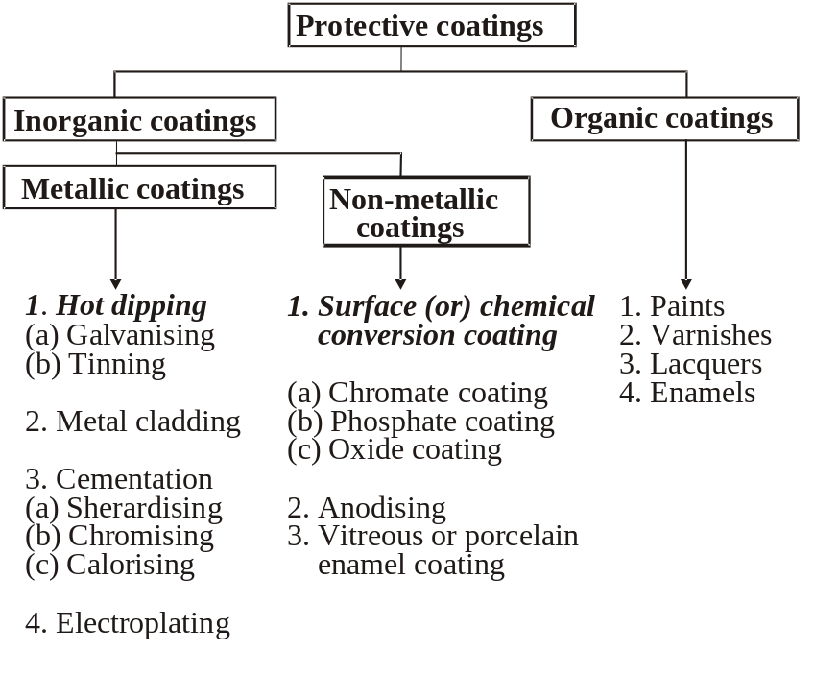
3.7 PRE-TREATMENT OF METAL SURFACE

The base metal surface is usually contaminated with rust, scale, oil, grease etc. If they are present at the time of coating, it will give porous and discontinuous coatings. Therefore inorder to get a uniform and smooth protective coatings, these substances should be removed by proper pretreatment methods. This is called as pre-treatment of metal surface.
They are

(i) Mechanical Method
These methods are useful to remove loose scale and oxides. The various methods are hammering, scraping, wire - brushing and sand blasting etc. Sand blasting is done when a slightly roughened surface is desired. It is the process in which sand or abrasives along with air steam under pressure of 25-100 atm is concentrated on the metal surface.

(ii) Chemical Method
These methods are mainly used for removing oils, grease, rust etc.,
a) Solvent Cleaning
Solvents such as alcohols, xylene, toluene, chlorinated hydrocarbons etc., are generally used in solvent cleaning. This is followed by cleaning with steam and hot water containing wetting agents.

b) Alkali Cleaning
In alkali cleaning chemicals like sodium hydroxide, tri sodiumphosphate, sodium silicate, soda ash etc., are used. This is useful in removing oil paints. This cleaning is followed by washing with 1% chromic acid solution.

c) Acid Pickling
Acids like H2SO4, HCl, HF, H3PO4 and HNO3 in dilute solutions are used for ferrous metals. For non-ferrous metals HNO3 with other acids is mainly used. The metals are dipped in side the solution at a higher temperature.

(iii) Electrochemical method
This method is used where the oxide scales cannot be removed by the other methods. The metal whose surface has to be cleaned is made either anode (Cathode pickling) or cathode (Anode pickling). The electrolyte is usually in acid solution or an alkali solution on passing a direct current, the dissolution of the oxide scales at anode or cathode takes place.
3.8 ELECTROPLATING (or)
ELECTRO DEPOSITION

(I) Principle
Electroplating is the process in which the coating metal is deposited on the base metal by passing a direct current through an electrolytic solution containing the soluble salt of the coating metal.
The base metal to be plated is made cathode of an electrolytic cell, whereas the anode is either made of the coating metal itself or an inert material of good electrical conductivity.
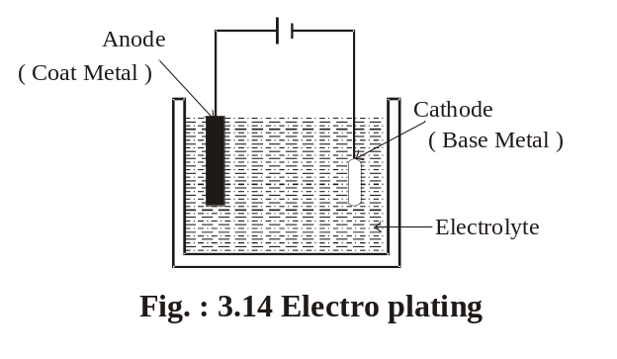
Example :
Graphite.

Objectives
1. On Metals
(i) To increase the resistance to corrosion of the coated metal.
(ii) To improve the hardness and physical appearance of the article.
(iii) To increase the decorative and commercial values of the article.
(iv) To increase resistance to chemical attack.
(v) To improve the properties of the surface of the article.

2. On Non-metals
(i) To increase strength
(ii) To preserve and decorate the surfaces of non-metals like plastics, wood, glass, etc.,
(iii) For making the surface conductivity by utilization of light weight, non-metallic materials.

(II) Theory
Suppose the anode is made of coating metal in the electrolytic cell. During electrolysis, the concentration of electrolytic bath remains unaltered, since the metal ions deposited from the bath on cathode are replenished continuously by the reaction of free anions with the anode.
Example : If CuSO4 solution is used as an electrolyte, it ionises as
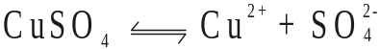
on passing current, Cu2+ ions go to the cathode and get deposited there.
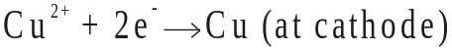
The free sulphate ions migrate to the copper anode and dissolve an equivalent amount of copper to form CuSO4.
The copper sulphate formed gets dissolved in the electrolyte. Thus, there is a continuous replenishment of electrolyte during electrolysis.

(III) Process
The article to be plated is first treated with dil. HCl (or) dil. H2SO4 to clean the surface. The cleaned article is then made cathode of an electrolytic cell. The anode is either the coating metal itself (or) an inert material of good electrical conductivity.

When direct current is passed from a battery, coating metal ions migrate to the cathode and get deposited there. Thus, a thin layer of coating-metal is obtained on the article (at cathode).
In order to get strong, adherent and smooth deposit certain additives (glue, gelatin, etc.,) are added to the electrolytic bath. In order to improve the brightness of deposit, brightening agents are added in the electrolytic bath. The favourable conditions for a good electro deposit are optimum temperature, optimum current density and low metal ion concentrations.

Characteristics of Various Plating

1. Nickel Plating
(i) It gives hard, adherent and good wear-resistant surface.
(ii) It is used as an undercoat for articles, which are finally to be
chromium-plated.

2. Chromium Coating
(i) It is porous and somewhat non-adherent.
(ii) The articles are first given an undercoat of copper or nickel, before chromium plating.

3. Copper plating

(i) It is an under coat for Ni-Cr electro deposit for smoothening
out the irregularities.
(ii) It is used as a protective coating for steel article.
(iii)It is coated at the bottom of stainless steel cooking utensils to
effect better heat transfer.
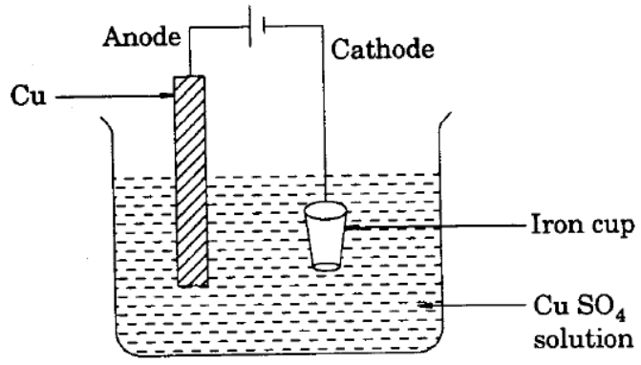

Fig Copper plating

Consider a iron cup is plated by copper metal.
For copper plating Cu metal is made as anode the iron cup is made as cathode and the CuSO₄ solution is used as electrolyte. When electric current is passed through the electrolyte, Cu²⁺ in the electrolyte deposit on the iron cup. Thus copper is coated on the iron cup.

4. Gold Plating
(i)The deposits of gold are used for electrical and electronic
applications.
(ii) It is used for high quality decorations and high oxidation
resistant coatings.
(iii)For jewellery very thin coating is given (0.05 - 1.0 microns).
Electroplating (Au)

Electroless plating(Ni)

Electroless plating is a technique of depositing a noble metal (from its salt solution) on a catalically active surface of a less noble metal by employing a suitable reducing agent without using electrical energy.

The added reducing agent causes the reduction of the metallic ions to metal which eventually gets plated over the catalically activated surface giving a highly uniform, but thin coating.
Thus
Metal ions + reducing agent Metal + Oixdized product(s)
Deposited over
Catalycally active
surface

The driving force is autocatalytic redox reaction on pretreated catalytic surface. Various aspects of electroless plating are:

1. Preparation of active surface of the object to be plated.
This step is most important in this technique. This is achieved by using one of the following methods:
i) Etching i.e. by acid treatment
ii) Electroplating a thin layer of the metal to be plated or any other suitable metal. This is usually followed by heat treatment.
iii) Treating with stannous chloride, followed by dipping in palladium chloride solution. This treatment yields a thin layer of Pd on the treated surface. Usually, this is followed in case of plastic and printed circuit board.

2. Plating bath is composed of :
i) Soluble slat of metal ( like chloride or sulphate) to be plated.
ii) Reducing agent like formaldehyde, hypophosphite etc.,
iii) Complexing agent like Tartarate , Citrate, succinate etc.
This improves the quality of the deposit.
iv) Exaltant like succinate, fluoride, glycinate etc.
This enhances the plating rate.
v) Stabilizer like Thio-urea, cations of lead, calcium, Thalium etc., is added to prevent the deposition of plating bath solution.

vi) Buffer like sodium acetate, sodium hydroxide plus rochelle salt, etc is added to control the pH of the bath. It may be pointed that pH of the bath plays a critical role in getting a uniform, but thin deposit.

Advantages of electroless plating over electroplating
1. No electrical energy is required.
2 Better throwing power.
3. Plating on articles made of insulators(like plastics) and semiconductors can easily be carried out.
4. Even intricate parts of (irregular shapes ) can be plated uniformly.
5. Electroless plated coatings possess unique mechanical, chemical and magnetic features.

Electroless Nickel plating

Electroless Nickel plating involves the following features:

Pretreatment and activation of the surface
The surface to be plated is first degreased (by using organic solvents or alkali), followed by acid-treatment.
a) Metals and alloys like Al, Cu , Fe, brass, etc. be directly nickel plated without any activation.

b) Stainless steel surface is activated by dipping in hot solution of 50% dilute H₂SO₄.
c) Activation of Mg alloy surface is carried out by giving a thin coating of Zn and Cu over it.

d) Activation of

Table 3.8 Differences between Electroplating and Anodising

3.17.3 Hot Dipping Method :
1. It is one of the most familiar method.
2.It is the very simple process.
3.It give good results.
4.In this method the base metal is dipped in a molten coat metal, for a particular time to get the uniform coatings.

5.The condition for succesful hot dipping methods are
(i) The coat metal having lower melting point than the base metal.
(ii) The coat metal must form an alloy with the base metal.
(iii) The base metal should with stand the high temperature of dipping without any change in properties.
(iv) Hot dipping is done on Fe with Zn, Sn and Al as coating metal.

The common examples of hot dipping are
1. Galvanising

2. Tinning

1. Galvanising :
It is a process of coating zinc over iron sheet (base metal),
Process : The base metal iron sheet is first pickled (pre-treatment) with dil. H2SO4 to remove any oxide coating present. It is then thoroughly washed with water. The cleaned dried iron sheet is dipped in a bath of molten zinc (coating metal) which is kept at 425 - 430OC. The surface of the molten coating metal is covered with NH4Cl flux to prevent the oxidation of molten coating metal to its oxide. (Fig. 3.18)

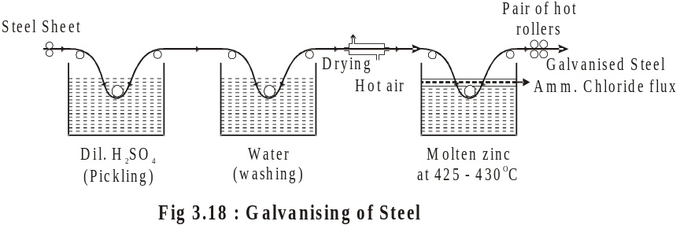

Due to the formation of a thin layer of an inter metallic compound (Fe3Zn10 or FeZn or FeZn13) at the interphase (base metal), a pure layer of zinc is tightly adhered to the iron sheet. The excess coating metal from the iron sheet is removed by passing through a pair of hot rollers.

Uses : Galvanised iron is used in automobile underbody parts, roofing sheet, lamp posts, etc.

2. Tinning :
It is a process of coating tin over iron sheet (base metal).
Process : The base metal is first pickled with dilute sulphuric acid to remove any oxide film present. It is then washed with water. The cleaned, dried base metal is dipped in a bath of molten tin which is kept at 230 - 235OC. The surface of molten coating metal is covered with ZnCl2 flux to clean the base metal further. In this process, palm oil is used to prevent the oxidation of molten coating metal (tin) to its oxide (Fig. 3.19).
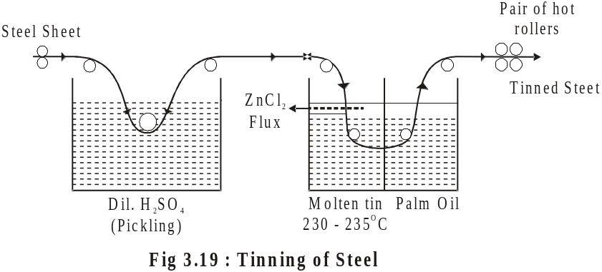

Due to the formation of a thin layer of Fe-Sn alloy (FeSn2) at the inter phase (base metal), a pure layer of tin is tightly adhered to the iron sheet. The excess coating metal from the iron sheet is removed by passing through a pair of hot rollers.

Uses : Tin-plated iron is used in food containers because of its non-toxic nature.

Table 3.9 Differences between electroplating and hot dipping

QUESTIONS :

1. What are the important constituents of a paint? Explain the function of the various constituents.
[BU. Nov ‘94, ‘95, ‘96, Apr ‘97; MSU. Apr, ‘97]

2. Bring out the similarities and dissimilarities in the electroplating and anodizing techniques. Give the application of the two.
[BU. Nov, ‘94.]

3. Distinguish the various organic coating from one another.
[MSU.Nov, ‘94]

4. How the hot dip process is carried our ?
[MSU. Nov, ‘94; MKU.Nov, ‘95, ‘96; Apr,’97.]

5. Describe the various features of anodizing of aluminium.

6. Describe the mechanisms of drying of an oil paint.
[BDU - Nov.‘95; Apr, ‘97; BU - Apr. ‘96; Mds - Apr. ‘99]

7. Write a note on surface preparation for metallic coating.
[BDU - Nov. ‘95; MKU - Nov. ‘95; Apr. ‘97; BU - Apr. ‘96]

8. Write a short note on various special paints.
[MSU-Apr. ‘95, Nov. ‘96; BU - Apr. ‘96, Apr. ‘97; Mds Oct. 98]

9. What are the main objectives of electroplanting. Give an account of the method used in electroplating of nickel on steel.
[Mds - Oct. ‘96, Apr. ‘99]

10. Discuss any two types of metallic coatings. [MKU - Apr. ‘95]

11. Write notes on : (i) Lacquers [MKU - Nov. ‘96]
12.Write briefly on (i) Types of varnish and their utility (ii) Anodising. [Mds - Oct. ‘97; BU - Apr. ‘96; MSU - Apr. ‘96]

13. How are galvanizing and tinning are carried out? Bring out the differences.
[BU - Nov. ‘95; MSU- Apr. ‘95, No. ‘96; MDS -Apr. ‘98]

14. What are surface conversion processes ? How do they prevent corrosion ? [BU - Nov. ‘95]

15. What are the constituents present in paint, varnish and lacquer? Mention their special qualities and uses ?
[Mds - Apr. ‘98]

16. What is electrode potential ?

17.Write the definitions of single electrode potential and standard electrode potential?

18.What is electrochemical series ? Give its significance.

